**IVANOV, Vyacheslav Ivanovich (ИВАНОВ, ВЯЧЕСЛАВ ИВАНОВИЧ) (1866-1949)**

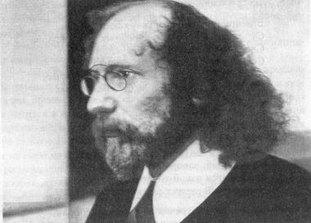Leading cultural figure of the Russian Silver Age. Born in Moscow, he died in Rome. Ivanov was a poet but had a greater impact as a translator of classical drama and poetry, a cultural and religious thinker, and a theorist of the “Dionysian” in theatre. A well-traveled and professorial figure (with long hair and spectacles), Ivanov was treasured as an interlocutor by other writers of the time. Ivanov married Lydia Zinovieva-Annibal (encouraging her to activate the second name in honor of her distant family ties to Alexander Pushkin). He moved to St Petersburg in 1905 and presided over “The Tower,” а meeting place/salon in his St Petersburg apartment. Almost everyone who was anyone came to present their new poetry and to participate in intense conversations and debates, discussing the urgent questions of the time, decadence, theosophy, mysticism, and the future of Russian society. After Zinovieva-Annibal’s sudden death in 1907, he married her daughter, his stepdaughter. In 1921 he defended a dissertation on the cult of Dionysus; in1924 emigrated from the Soviet Union, and in 1926 he converted to Catholicism. Ivanov spent the rest of his life in Italy, where he taught and composed scholarly publications.

**References and Further Reading**:

Bird, Robert (2006). *The Russian Prospero: The Creative University of Viacheslav Ivanov*. Madison, WI: University of Wisconsin Press.

Davidson, Pamela (1989). *The Poetic Imagination of Vyacheslav Ivanov: A Russian Symbolist’s Perceptions of Dante*. Cambridge: Cambridge University Press.

---------- (1996). Viacheslav Ivanov: A Reference Guide. New York: G. K. Hall.

Jackson, Robert Louis and Lowry Nelson, Jr., eds. (1986). *Vyacheslav Ivanov: Poet, Critic and Philosopher*. Columbus, OH: Slavica Publishers.

Wachtel, Michael (1994). *Russian Symbolism and Literary Tradition: Goethe, Novalis, and the Poetics of Vyacheslav Ivanov*. Madison, WI: University of Wisconsin Press.

West, James (1970). *Russian Symbolism: A Study of Vyacheslav Ivanov and the Russian Symbolist Aesthetic*. London: Methuen.

**Major works**:

**Poetry**:

Kormchie zvezdy. Kniga liriki (*Guiding Stars: A Book of Lyrics*) [1903]

Prozrachnost'. Vtoraia kniga liriki (*Transparency. A Second Book of Lyrics*) [1904]

Eros [1907]

Cor Ardens [in two parts: 1911, 1912]

Nezhnaia taina. Lepta (*Tender Secret. The Mite*) [1912]

Mladenchestvo (*Infancy*) [1918]

Zimnie sonety (*Winter Sonnets*) [1920]

Chelovek (*Man*) [1939]

**Plays**:

Tantal (*Tantalus*) [1905]

Prometei: Tragediia (*Prometheus: A Tragedy*) [1919]

**Essays and Criticism**:

Po zvezdam. Stat'i i aforizmy (*By the Stars: Articles and Aphorisms*) [1909]

Borozdy i mezhi. Opyty èsteticheskie i kriticheskie (*Furrows and Abutments: Esthetic and Critical Essays*) [1916]

Rodnoe i vselenskoe. Stat'i (1914-1916) (The Familial and the Universal: Articles, 1914-1916) [1917]

Perepiska iz dvukh uglov (*Correspondence from Two Corners*), with M. O. Gershenzon [1921]

Dostojewskij: Tragödie – Mythos – Mystik (*Freedom and the Tragic Life: A Study in Dostoevsk*y) [1932]

**Sibelan Forrester, Swarthmore College**

Source url for image:

<http://www.silverage.ru/images/ivanov_zannib/iv_zan_foto.html>

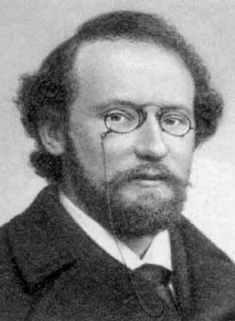

<http://www.poesis.ru/poeti-poezia/ivanov/biograph.htm>